LAPORAN KUIS BASIS DATA

KUIS 2

Oleh:

FARID AZIZ WICAKSONO

NIM. 1841720094



PROGRAM STUDI TEKNIK INFORMATIKA

JURUSAN TEKNOLOGI INFORMASI

POLITEKNIK NEGERI MALANG

APRIL 2019

1. Tabel Deskripsi
2. Tabel Konsumen

|  |  |  |  |  |
| --- | --- | --- | --- | --- |
| kode_konsumen | nama | no_telepon | email | keterangan |
|  |  |  |  |  |

1. Tabel Booking

|  |  |
| --- | --- |
| kode_booking | Tanggal |
|  |  |

1. Tabel Meja

|  |  |
| --- | --- |
| no_meja | detil_meja |
|  |  |

1. Tabel Pesanan

|  |  |
| --- | --- |
| kode_pesan | tanggal |
|  |  |

1. Tabel Staf

|  |  |  |
| --- | --- | --- |
| kode_staf | Nama_awal | Nama_akhir |
|  |  |  |

1. Tabel Peranan

|  |  |
| --- | --- |
| kode_peranan | Nama_peranan |
|  |  |

1. Tabel Menu Pesanan

|  |  |  |
| --- | --- | --- |
| kode menu_pesanan | kuantitas | komen |
|  |  |  |

1. Tabel Menu

|  |  |
| --- | --- |
| kode_menu | tanggal |
|  |  |

1. Tabel Item Menu

|  |  |  |
| --- | --- | --- |
| kode item_menu | keterangan | harga |
|  |  |  |

1. Tabel Item Bahan

|  |  |
| --- | --- |
| kode item_bahan | kualitas |
|  |  |

1. Tabel Bahan

|  |  |
| --- | --- |
| kode_bahan | nama_bahan |
|  |  |

1. Tabel Tipe Bahan

|  |  |
| --- | --- |
| kode tipe_bahan | deskripsi |
|  |  |

1. CDM

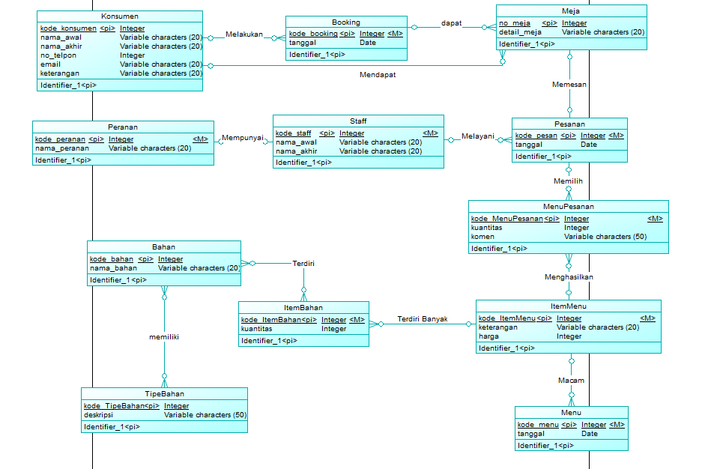

1. PDM

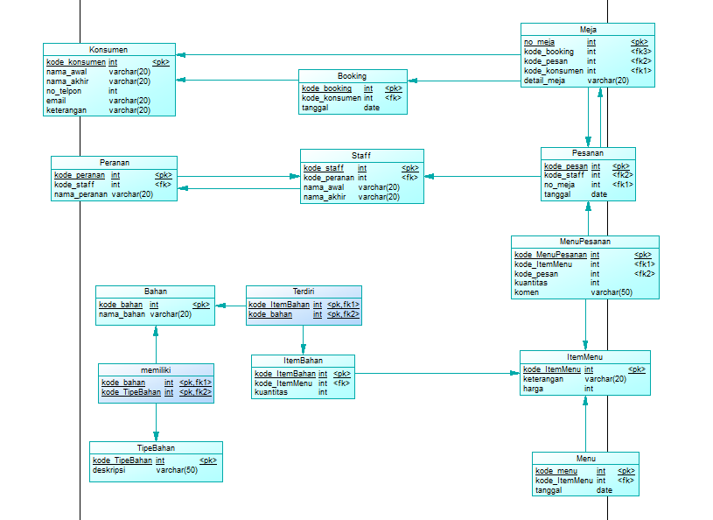

1. LDM

